Chapter 8, Problem 62.

Find the response v_{R}(t) for t > 0 in the circuit in Fig. 8.107. Let R = 3 Ω, L = 2 H, and C = 1/18 F.
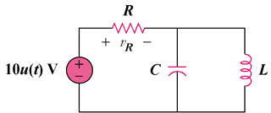

Figure 8.107
For Prob. 8.62.

